Czech Radio
Creative Group Literature, Drama and Entertainment
Dramaturgy by Klára Novotná
Directed by Natália Deáková
Sound design: Jan Trojan
Sound engineer: Dominik Budil
Production assistant: Dana Reichová
Station: Czech Radio Vltava
First broadcast: 28 January 2025

Eva Blechová

Radiant Child

The Luminous and Sombre Story of Marie Curie and Radium

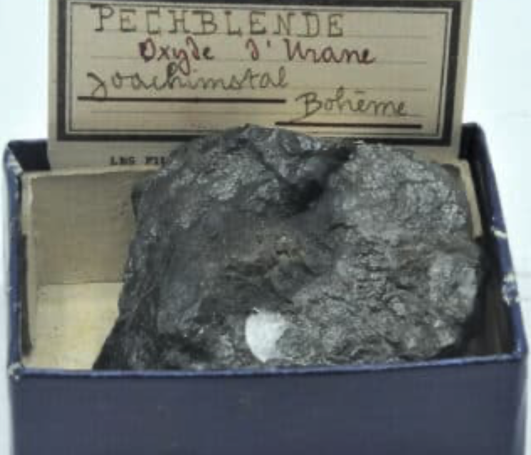

pitchblende sample from Jáchymov

Characters and cast
M - Marie - Klára Suchá
R - Radium - Petr Uhlík
Narrator 1 (female voice) - Natália Drabiščáková
Narrator 2 (male voice) - Jakub Žáček
Narrator 3 (male voice) - Jan Vondráček

French voices: Anna Kubišta, Guillaume Narguet
Polish voices: Maria Gniłka-Somerlik, Richard Kulczycki
Swedish voice: Martin Severýn

Prologue
(translator’s note: the letter count works in Czech, not necessarily in English) OBECNĚ POZNÁMKY PŘEKLADATELE DO TITULKŮ NEDÁVAT, ALE TADY BY TO MOŽNÁ BYLO DŮLEŽITÉ? NECHÁVÁM NA VAŠE ZVÁŽENÍ …

1 city in five letters
2+3 Paris
1 scientist in five
2+3 Nobel, Fermi, Pauli, Tesla, Volta, Euler
1 chemical element in five
2+3 lead, astat, fluorine
1 scientist in six
2+3 Newton, Hubble, Lorenz
1 female scientist in six
(silence) 2+3 Well, I nearly got it ...
1 chemical element in six
2+3 zinc, barium, erbium, helium, yttrium, gallium, radium
1 scientist in seven
2+3 Fleming, Hawking
1 female scientist in seven
(silence) 2+3 I don't know, keep going
1 city in seven
2+3 Warsaw, Jáchymov
1 scientist in eight
2+3 Poincaré, Theremin, Einstein
1 city in eight
2+3 Hiroshima, Nagasaki, Chernobyl, Fukushima
1 female scientist in eight
2+3 CURIEOVÁ
(translator’s note: in Czech language, „ová“ is added as a suffix for female names)

1 Radiant Child
2 The rise and fall of RRRadium. 3 A Radio Play.

Questionnaire - part 1
3 name
M Marie Salomea Curie, née Skłodowska. Also Mania. Maria. Manusha.
R Radium, from Latin radius - ray. Abbreviation Ra. RRRa. R. A.
2 birth
M 7 November 1867 in Warsaw.
R In supernova collisions. Everywhere.
1 appearance
M High forehead, grey eyes, Slavic features. Dresses in black.
R Perfectly white when in a pure state. Turns black fast when exposed to air.
3 price/prize
M Nobel Prize in Physics. In 1903.
R 40 million dollars per pound. In 1908.
M Nobel Prize in Chemistry. In 1911.

(Thunderous applause. Nobel Prize award ceremony, Stockholm, 1911. Speech by Marie at the banquet)
M "Allow me also to express the joy I feel when I think of radioactivity. The discovery of radioactive phenomena is only fifteen years old. Radioactivity is therefore a very young science. It is a child I saw coming into the world and for whose upbringing I have done my best. That child grew up and became beautiful. "

"Qu'on me permette en outre d'exprimer la joie que je ressens en pensant à la radio-activité. La découverte des phénomènes radio-actifs ne date que de quinze ans. La radio-activité est donc une science très jeune. C'est un enfant que j'ai vu naître et que j'ai contribué, de toutes mes forces, à élever. L'enfant a grandi, il est devenu beau."

1 The child grew up and became beautiful.
R Beautiful?
2 Back then, radium is still beautiful

Encounter
3 It was improbable.
1 It took effort.
2 And ingenuity.
3 And luck.

1 She with a diploma from the Sorbonne.
2 Top of her class.
3 First in physics. 2 Second in mathematics.
1 She is looking for a topic for her doctorate.
2 Something new.
3 An outsider must have something new.

1 It lies hidden in the pitchblende.
2 In what?
3 Pitchblende.
1 Glossy black rock forming a kidney-shaped mass. It raises expectations.
3 But where the pitchblende begins, the silver vein ends.
2 Every miner in Jáchymov knows this. Has known for centuries.
R Unlucky rock. Devil's stone. Pechblende. Misfortune.
1 Then in pitchblende they find uranium. It colours glass. Light green. Yellow.
3 Uranium is extracted from pitchblende. Tons of waste remain.
1 Heaps and heaps. Lying in the corner of the factory.
3 Nobody wants it.
R What would anyone do with it?

2 She is searching for a topic for her doctorate.
3 Everyone is studying the new and strange X-rays.
1 But she wants something else.
R Something more original.
3 Even stranger: Becquerel rays.
2 Even Becquerel himself has lost interest.
1 The Director of the Natural History Museum was never interested.

M I would like to borrow rock samples from your museum for my research.
3 (museum director) For your research?
M For my doctorate at the Physics department at the Sorbonne.
3 You?
M I will investigate Becquerel's rays.
3 But no one understands them.
M Yes, that's why I will study them.
3 You have a lab?
M I work in the lab of Dr. Curie at the Municipal School of Physics and Chemistry.
3 Dr. Curie, is that your father?
M My husband.
3 Ah...
1 It's a long list.
(rustling of papers)
Orangite, monazite, aeschynite, carnotite, pitchblende, thorite...
3 I can only provide you with a few of those.
M For what reason?
3 What could aeschynite or thorite have to do with uranium? Why would they emit anything?
M With respect, the list is the result of extensive consideration. I don't want to miss anything. Could I pick them up tomorrow?
3 Well, well ... you are in a hurry …
M It's about... my child.
3 Your child?
M Yes.
(rises)
3 Wait, your are about to -
M Give birth? Yes, in about a month. That's why I need the minerals as soon as possible.

2 Marie and Pierre Curie are delighted to announce the birth of Irène.
1 She was born on September 12, 1897.
3 She radiates (translator’s note: in Czech “září” means both September and “radiates”)
2 But Marie continues to work on her doctorate.
1 She is systematic.
R She measures everything, records everything.
2 She has Pierre's precise electrometer.
3 Orangite, monazite, aeschynite, carnotite, thorite…
1 And so she measures the pitchblende.
2 It radiates more than it should.
3 And so she discovers ... polonium
R And so she discovers … radium
1 It emits 900 times more than uranium.
2 It is the fruit of effort.
R And also of chance.
3 It's an improbable encounter.
1 She did not spare herself.

2 MaRie and PieRRe CuRie are delighted to announce the birth of RRadium. Ho!
1 It was born on 18 December 1898.
3 It radiates.
2 A new strongly RRadioactive element present in pitchblende.
3 The parents think it is teRRific!
R Rrradium.
1 A ray.
2 She doesn't know whether she or Pierre came up with the name.
3 They both made notes in the lab journal.
2 Her handwriting is more precise, his more flowing.
1 They publish eight days later, on December 26, 1898.
2 It is out in the world.
3 It is public.
R It is official.
"These reasons lead us to believe that the new radioactive substance contains a new element, to which we propose to give the name of RADIUM. The new radioactive substance certainly contains a large quantity of barium; yet its radioactivity is considerable. The radioactivity of radium must therefore be enormous."
"Ces raisons nous portent a croire que la nouvelle substance radio-active renferme un élément nouveau, auquel nous proposons de donner le nom de RADIUM. La nouvelle substance radioactive renferme certainement une tres forte proportion de baryum, malgré cela, la radio-activité est considérable. La radio-activité du radium doit donc être énorme."

3 enoRRRmous radioactivity
1 active,
3 radio-activité énoRRRme
1 "agere", to act
2 it acts by radiating
R ago, agis, agit, agimus, agitis, agunt
1,2,3 It radiates!

Questionnaire - part two
1 occurrence
M Warsaw. Paris. Sometimes Brittany or the Côte d'Azur.
R Everywhere. Absolutely everywhere. In greater amounts in the Ore Mountains, Canada, Congo, Utah, Colorado.
2 order
M Fifth child of Bronislawa and Josef Skłodowski. Mostly first in everything.
R Sixth in the series of alkaline earth metals.
3 weight
M 46 kilograms. That is less than before.
R Atomic weight 226. Fits perfectly in the Mendeleev table of elements, as number 88, between francium and actinium.
1 Like an ass on a pot. (translator’s note: Czech idiom for something fitting well, in English probably „fits like a glove“)

M I took eight pounds of red currants and the same amount of crystal sugar. I let it simmer in the pot for ten minutes, then strained it through a fine sieve.
R She measures everything, records everything.
M That was enough for fourteen bottles of clear jelly, dark and beautifully set.

3 Grind.
2 Dissolve.
1 Stir.
3 Filter.
2 Cool.
1 Purify.
3 Grind..
2 Dissolve.
1 Stir.
3 Filter.
2 Cool.

1 Fractional crystallisation.
3 Pierre tries to talk her out of it.
2 There is no need. They've already proven the existence of radium.
R But it's not enough for her.
1 Theoretical proof is not enough for her.
2 Measuring radiation is not enough for her.
1 She wants to see radium.
2 She wants to show it to the world.
R Chemical persistence.

1 She will have her way.
2 Pitchblende travels from Jáchymov to Paris.  By train. From the Ore Mountains via Stuttgart to Gare de l'Est.  1 She received part of it for free from the Austrian government.  Black substance mixed with pine needles. Twigs. Dirt. | 3 January 1899 - 100 kilograms of pitchblende travel from Jáchymov to Paris  July 1899 - 1 ton of pitchblende from Jáchymov to Paris.  November 1899 - 1 ton of pitchblende from Jáchymov to Paris.
2 Baron de Rothschild paid for the rest.  Fifteen tons in total. | March 1900 - 3 tons of pitchblende from Jáchymov to Paris.  June 1900 - 3 tons of pitchblende from Jáchymov to Paris.  February 1902 - 5 tons of pitchblende from Jáchymov to Paris.

1 Purify.
3 Grind.
2 Dissolve.
1 Stir.
3 Filter.
2 Cool
1 Purify.
3 Grind.
2 Dissolve.
1 Stir.
3 Filter.
2 Cool.
1 Purify.
3 Grind.
1 Stir.
3 Filter.
2 Dissolve.
1 Cool.

1 Four years of work. Physical work.
M "Sometimes I had to spend all day stirring the boiling mass with a heavy iron rod that was almost as big as me. At the end of the day I was overcome with fatigue.
"Je passais parfois la journée entière a remuer une masse en ébullition, avec une tige de fer presque aussi grande que moi. Le soir, j'étais brisée de fatigue.

R From this, the myth of Marie Curie would later crystallise.
2 From fifteen tons of pitchblende, one-tenth of a gram of radium salts.
1 A quarter teaspoon of white powder at the bottom of a test tube.
3 The air around glows blue.
2 It is a miracle.
1 It is her child.

2 Marie's aging father, a physics professor, congratulates her from Warsaw.

3 (father) And so you have in your hands pure radium salts! Considering the amount of work that has gone into obtaining them, it is surely the most expensive of the chemical elements. It is a pity that this work seems to have only theoretical significance.
Oto jesteście w posiadaniu czystych soli radu! Biorąc pod uwagę ilość pracy włożonej w jego uzyskanie, jest to z pewnością najdroższy z pierwiastków chemicznych. Szkoda tylko, że, jak się wydaje, praca ta ma jedynie znaczenie teoretyczne.

R A double-edged compliment.
2 Jedynie znaczenie teoretyczne.

Enchantment
1 Their first child they name Irène.
3 Their second child they name Radium.
2 The next child they do not name.
1 They lose it.

(letter to Bronia, August 1903)
Dear Bronia, my dear sister, I am devastated by misfortune, I don't even feel like writing. I got so used to the idea of having a baby that I can't calm down. Write if you think it was general fatigue. I must confess to you that I have not been sparing myself. The baby - it was a girl - was pretty well developed and already alive. I wanted the child so much!
Droga Broniu, moja siostrzyczko, jestem zdruzgotana nieszczęściem, nawet nie chce mi się pisać. Tak się przyzwyczaiłam do myśli o dziecku, że nie mogę się uspokoić. Napisz, jeśli myślisz, że to przez ogólne zmęczenie - bo muszę przyznać, że się nie oszczędzałam. Dziecko - to była dziewczynka - było dobrze rozwinięte i już żyło. Tak bardzo go pragnęłam!

1 sheer exhaustion
2 ogólne zmęczenie
3 fatigue générale
1 fifth month of pregnancy
2 1903
3 she is 36 years old
1 she has a doctorate in physics, the first woman in France
3 she is tired
and empty
2 she must admit that she did not spare herself.
R She rubs her black fingers against each other.

1 Life must be put in order again.
2 She runs the household.
3 Systematically.
1 She has three notebooks
2 one for daily entries
3 second for a draft at the end of the month
1 third with columns.
R She writes and rewrites, adds and checks.

3 rent, taxes, food, heating, lighting,
2 laundry, clothing repairs, staff wages, expenses Monsieur, expenses Madame
1 expenses children, illnesses, furniture, transportation, luxuries, miscellaneous
loyer, impôts, frais de table, chauffage, éclairage, blanchissage, raccommodage, gages d'employés, entretien de monsieur, de madame, des enfants, maladies, mobilier, voiture, fantaisies, frais divers

M salary Pierre 816 francs
shoe repair 6 francs 50 centimes
red wool for Irène 1 franc
wages for the nanny Marthe 20 francs
matches 35 centimes
1 when something is missing or in excess
2 when something doesn't add up, she puts an exclamation mark

lace 1 franc 45 centimes
hat for Irène 1 franc 25 centimes
repair of Pierre’s trousers 13 francs
Nobel Prize 70 thousand francs
(speech at the Nobel Prize in 1903, Dr. H.R. Törnebladh, President of the Swedish Academy of Sciences ,)
3 "Finally, we have discovered a new source of energy for which we do not yet have a full explanation. It will probably result in new research of the highest level in physics and chemistry. This discovery alone heralds a new era in the history of the physical sciences.”

Slutligen har vi funnit en ny energikälla, som vi ännu inte har någon fullständig förklaring till. Den kommer naturligtvis att ge upphov till ny forskning av allra högsta värde inom fysik och kemi. Enbart denna upptäckt innebär början på en ny era i fysikens historia.

Questionnaire - part three
2 time of greatest fame
M+ R after the Nobel Prize in 1903
3 number of articles in the press
M I did not count them.
R She didn't count?
1 most frequently mentioned information in the press
R It emits heat spontaneously. It glows in the dark. It is a miracle.
M She is a woman! A woman who thinks. It is a miracle.

2 Journalists are let off the leash.
1 a female scientist
3 the first woman with a Nobel Prize
1 with a scientist husband
2 They have never seen that before.
3 “a romance in the physics laboratory”
1 "marriage metal"
2 "Little Miss Irène dines all alone, so that her mummy may win the Nobel Prize"
1 Irène does not like the laboratory.
3 She says it is an ugly, ugly place.

R Radium is the brightest debutante of the 1903 season.
2 "Radium, a word as luminous as the substance it describes, was suddenly on everyone’s lips. It had a festive ring to it that appealed to people.
R RRRadium!
2 It sounded bright, sunny, and cheeRRful to pronounce."
"Le radium, mot radieux et rayonnant comme la substance qu'il désigne, fut en un instant dans toutes les bouches. Il avait un air de fête qui plaisait. Radium ! Cela faisait clair, ensoleillé et joyeux à prRRononcer."

1 This was written by natural scientist Camille Flammarion in 1904.
2 It sounds sunny.
3 Rayonnement. Radiation.
2 Promienowanie. Radiacja.
1 The child is so beautiful.

1 They come to the laboratory to watch it in the evening.
M Do you remember, a few years ago you told me: I wish radium had a beautiful colour?
2 (Pierre) It is like fireflies. Fairies.
M I feel like I've been given a gift from heaven.
2 I thought you didn't believe in heaven?
M Not in God. But I think I won some kind of cosmic lottery.
2 It is the light itself. It seems to float.
M Our light.
2 Our light.
R Your light?

3 She keeps it on her bedside table in a vial.
2 It glows in the dark.
3 It defies the laws of physics.
1 The child is so beautiful.

2 Marie and Pierre Curie are delighted to announce the birth of Ève. She came into the world -
R Just now? Really?
1 The Curies don't know where to start.
3 Journalists. Fame. Research.
2 They send a telegram to Warsaw
M 8 francs 45 centimes
1 they have champagne
M 5 francs
3 and hire a wet nurse right away
M 60 francs

3 The radium craze is in full swing.

1 Radium will soften your skin.
2 Radium will help your hair grow.
3 It will cure blindness.
1 It will cure infertility.
2 It will whiten the skin of black people.
3 It will slow down aging.
1 Radium will heat your home.
2 Radium will heat all households.
3 It will be so cheap that we'll throw away all the power meters.

1 radium healing pads
2 radium condoms
3 radium suppositories
1 radium toothpaste
2 radium face cream
3 radium shoe polish
1 radium lipstick
2 radium tea
3 radium bread
1 radium ice cream

2 "radium" is synonymous with quality
3 "Radium" is synonymous with effectiveness
2 "radium" is cool

In parallel, several pieces of advertising from the period

1 “Radium will shine on some future civilisation centuries from now, and will save thousands of human lives through the ages.”
3 "Tho-Radia scientific cream based on thorium and radium, according to the recipe of Dr. Alfred Curie. Available exclusively at the pharmacy.
2" Blue Radio golf ball: when the ball is hit, the radium salts in the plastic center start a wave of momentum which gives a great resiliency. The ball literally is alive and the released energy actually fights to free itself.”

1 + 2 + 3 You hoo, plop, plop ….

1+2 Lip. Dip. Paint.
+ 3 Lip. Dip. Paint.
1+2+3 Lip. Dip. Paint
2 It's the best job in town
3 In Orange, New Jersey, in Ottawa, Illinois, in Waterbury, Connecticut To paint numbers on watch dials that glow in the dark.
2 Dip in colour.
1 Take a brush of camel hair. Put it to your lips, lick and sharpen.
2+3 Lip. Dip. Paint. Lip. Dip. Paint.
1 3,250 dials a day.
20 dollars a week.
1+2+3 Lip. Dip. Paint.

Alone
M Stop it!
1 Pierre is dead.
M Completely dead?
R Hmm. Completely.
M My Pierre?
2 "Pierre Curie carried out the most dangerous experiments in his humble laboratory. But in the end, he died like an ordinary man slipping under a heavily loaded cart."
M Bronia, they gave me back his keys, his wallet, his fountain pen, his calling cards, his watch.
1 "Madame Curie, supported by her father-in-law, accompanied her husband's coffin to the grave. There she stood motionless for a moment, her gaze fixed and stern."
M The watch is still ticking. What am I to do with that?

2 She does not want anyone to mention his name.
3 She does not want the children to run or raise their voices at home.
1 She does not want anyone to speak loudly.
M I want silence.
R Silence.

2 But she is famous.
1 She is a widow.
3 Veuve illustre.
1 She has to manage alone.
To take care of Irène.
To take care of Ève.
R To take care of radium.
A single mother.
3 She will manage.
2 She receives another Nobel Prize.
R Just herself.
1 Alone.
2 This time she shares it with no one.

(receiving the Nobel Prize in 1911)
M "It is a child I saw coming into the world and for whose upbringing I have done my best. That child grew up and became beautiful."
C'est un enfant que j'ai vu naître et que j'ai contribué, de toutes mes forces, à élever. L'enfant a grandi, il est devenu beau.

1 She will not be naming any more children.
3 She must undergo a hysterectomy.
2 She feels best in the laboratory.
1 She does not spare herself.
R She has a vial of radium on her bedside table.
It glows in the dark.
M “Nothing can bring me inner joy, except perhaps scientific work”.
3 It is a pity that this work seems to have only theoretical significance.
Szkoda tylko, że, jak się wydaje, praca ta ma jedynie znaczenie teoretyczne.

1 Radium destroys the DNA of cancer cells.
2 It causes them cellular death.
R Mitotic catastrophe.
3 Cells die when they try to divide because of chromosome damage.
M We need money for further research.
1 She wishes radium to be useful.
R Beneficial to humanity
3 She travels to America.
2 The New York Times reports on the front page, "Madame Curie Plans to End All Cancers."
M I've never said …
R RRR
3 "Madame Curie says that radium is a sure cure, even in deep-rooted cases, if properly treated."
M It's not quite certain yet, although I hope …
R RRR
2 “Madame Curie's dress was severely plain. She wore a black, loose-fitting tailored suit and a black taffeta hat, with gloves of the same colour."
M I request a correction!
1 The New York Times prints it on page ... 16: "Radium Is Not a Cure for All Types of Cancer."
R Radium is not a cure for all types of cancers.

Questionnaire_part four
3 half-life
R 1600 years
M Thirty-three and a half years.
1 function
M Director of the new Radium Institute. On the new Pierre Curie street in Paris.
R Radiotherapy. Dial painting. Creams.
2 appearance
M High forehead, tired grey eyes, Slavic features. Always in black.
R Perfectly white when in a pure state. Turns black fast when exposed to air..
3 favourite music
M Third Nocturne by Franz Liszt. Ève plays it on the piano. She is gifted.
R The sound of the Geiger counter.

(tinnitus in sound and in speech)
1 the buzzing of bees
3 whistling trains
2 hissing taps in the laboratory
1 fish frying
3 steam escaping from a teapot
2 chains on gravel
1 bells from a church in Warsaw
3 Franz Liszt's 3rd Nocturne
2 sounds that cannot be measured
1 continuous
2 sounds no one else can hear
1 bells
3 nocturne
2 tinnitus
1 day and night
M they are everywhere
R they are everywhere
M they never stop
R they never stop
1 you can't get rid of them
2 not even by rubbing black fingers against each other
3 nor by scientific work
3 nor by staying in the laboratory

Black fingers
M Stop it!
2 Maurice Démenitroux. 35 years old. Chemist.
3 Marcel Delamander. 41 years old. Chemist.
M Dead?
2+3 Hmm..
R Completely.
2 They both worked with radium.
M They did not aerate enough.
3 Both had earlier worked in her lab.
1 She knew them.
M They did not protect themselves.
R They did not protect themselves?
M "I am not aware of any serious accidents caused by radium among the staff of my institute. Mr Demenitroux and Mr Demalander were working with very strong concentrations of radium in a small unventilated room and without a protective screen. Yet it is necessary to warn both industrialists and engineers themselves of the dangers of radium."
Je n'ai pas connaissance d'accidents graves causés par le radium parmi le personnel de mon institut. Messieurs Demenitroux et Demalander travaillaient avec de très fortes concentrations de radium dans une petite pièce non ventilée et sans écran de protection. Néanmoins, il est nécessaire de mettre en garde les industriels et les ingénieurs eux-mêmes contre les dangers du radium.

1 Marie massages her fingertips.
3 Dry skin. Peeling. Pruritus. Hyperpigmentation.
2 Black fingers as a reminder.
1 Black fingers as a pointer.
R Black fingers as a signpost.

1 Everyone in her lab undergoes regular and mandatory blood tests. Except her.
M It is a child I saw coming into the world and for whose upbringing I have done my best.
C'est un enfant que j'ai vu naître et que j'ai contribué, de toutes mes forces, à élever.
R A child surely cannot be dangerous! Can it?

Lip. Dip. Paint.
Lip Dip. Paint.
Lip. Dip. Paint.
Lip. Dip. Paint.
Etc.

In parallel
1 The dial painters in New Jersey are dying.
3 Katherine. Edna. Quinta. Amelia.
2 Grace.
3 More than fifty dead women.
1 They are young.
2 They were healthy.
1 Those girls' hair is falling out.
2 Their teeth.
3 Their gums disintegrate.
1 And their bones.

M What was the concentration of radium?
3 One part of radium to 30 thousand zinc sulphate.
M That is a low concentration.

R They are disintegrating.
M If this... illness... were caused by radium, then...
R Pitchblende. Unlucky rock.
M If radium were deadly...
R Well then, that is bad luck. .
M…. I should have been long dead … myself.
R Hmm...

1 Her eyes get worse and worse
2 That is why everyone thinks she is strict.
1 But she does not see them.
3 Or hear them.

(letter to Bronia, November 1920)
M "Dear Bronia, my eyes have become very weak. And as for my ears, I am haunted by an almost constant humming. It worries me greatly: my work may be affected. Perhaps radium has something to do with these troubles, but it cannot be confirmed with certainty."
M: Droga Broniu, moje oczy stały się bardzo słabe. A jeśli chodzi o moje uszy, to nawiedza je niemal nieustanny szum. Bardzo się martwię: może to mieć wpływ na moją pracę. Być może rad ma coś wspólnego z tymi kłopotami, ale nie da się tego z całą pewnością potwierdzić..

R It cannot be confirmed with certainty.

1 She hides her illnesses.
2 She puts coloured labels on the instruments so she can recognise them.
1 She writes her lecture notes in enormous letters.
3 After all, she is the director of the Radium Institute. Directrice de l'Institut de Radium.
2 She is Madame Curie. Veuve illustre.
1 Four eye operations.
2 She checks into the hospital under a false name.
3 Madame Carré
R Mrs. Square.

M salary from the Sorbonne 2168 francs 75 centimes
dentist Ève 120 francs
flowers for the cemetery 14 francs
jam making 32 francs 50 centimes
postage from Prague 1 franc 5 centimes

(letter to Irène from Prague, 14 June 1925)
M Dear Irène, this morning I arrived in Prague and tomorrow evening I leave for Jáchymov. I am bewildered by the life I lead and unable to write you anything sensible."
Chère Irène, je suis arrivée a Prague ce matin et partirai demain soir pour Jachymov. Je suis ahurie de la vie que je mène et incapable de te dire quelque chose d’intelligent.

2 Gala dinner at the Municipal House.
3 Two days in Lány with President Masaryk.
1 "Apart from scientific matters, she showed little interest in anything else."
3 “In Prague, someone suggested showing Madame Curie St. Vitus Cathedral. She refused almost angrily."
M "A church! They are as dark as a grave. Let us stay in the open air instead."
1 In Jáchymov, she descends into the Svornost mine.
2 She has to sign a waiver, that this is at her own risk.
1 They show her a newly discovered 4-metre high vein and name it after her.
3 They give her a piece of pitchblende as a souvenir.
R She takes it by train to Paris. Choo, choo!

(tinnitus sounds)
1 she rubs her black fingers
2 still working into the night
3 she works herself to exhaustion
1 she is angry with herself
2 she is angry with Pierre for dying
2 she is angry with the children
3 she is angry with God,
in whom she stopped believing at eleven, when her mother died
2 perhaps she is sometimes angry with science
R she cannot be angry with science
1 because science is like a religion
3 Science is like God,
to which sacrifices must be made
("lip, dip, paint")
1 on an altar full of test tubes
2 especially when they glow softly and blue

3 she likes to quote Pasteur
R "the laboratory is a sacred place"
M " in which humanity grows, improves itself and becomes better"
2 how else can we learn the secrets of the universe
1 how else can we find out how things are

3 being a martyr to science, she can do that
2 not spare herself
1 to work until total fatigue
2 do ogólnego zmęczenia
3 jusqu'à la fatigue générale
1 not wearing gloves in the laboratory
3 pipetting by mouth
1 rubbing her black fingers
2 slowly disintegrating

R I am everywhere.
I am unseen.
I am unheard.
I am unsmelled.
Every second, dozens of muons - unstable particles created by cosmic radiation - pass through your body.

3 when radium enters the blood
the body mistakes it for calcium
2 radium settles in the bones
destroys the bone marrow
1 in some people less
in some people more

R I am in your floor.
I am in your wall.
I am in every meal you eat.
Well yes. In avocados or in bananas even more.

2 she keeps radium on her bedside table
3 though now she now knows it must be kept in lead boxes
1 though she now knows that the child
2 her child
3 is radiant and dangerous
1 and is disintegrating
2 slower than her
3 slower than us

R Are you afraid?
At first you loved me.
You used to add me to creams.
You composed songs about me.
Twenty years were enough.

Pierre was afraid even then.

( Pierre Curie's Nobel Prize acceptance speech in 1905)
2 It can even be conceived that radium might become very dangerous in the hands of criminals. And here the question arises whether mankind is prepared to profit by the knowledge of the secrets of nature, or whether such knowledge will not be harmful to it."
On peut concevoir encore que dans des mains criminelles le radium puisse devenir très dangereux, et ici on peut se demander si l'humanité a avantage à connaître les secrets de la nature, si elle est mûre pour en profiter ou si cette connaissance ne lui sera pas nuisible.

1 She too is not sure whether humanity is ready.
3 She will not live to see advances in radiotherapy.
1 She will not live to see nuclear power plants.
2 She will not live to see Hiroshima and Nagasaki.
1 She will not live to see Chernobyl.

3 But she was in one war.
2 Verdun. La Somme. Calais. Dunkirk.
3 She and Irène drove mobile X-ray machines.
They called them "les petites Curies".
2 She saved the arms, the legs, the lives of soldiers.
1 She saw the trenches.
She heard the machine guns.
She smelled mustard gas.
2 She survived the war.
She survived the scandals.
She doesn't want any more drama.

Half-life
R For example, polonium will kill you quickly.
Just add it to sushi. Or to tea.
Me? I'm radiating. Quietly. Subtly.
I am decaying. Slowly.
Well, I cannot do otherwise.
3 She is famous.
1 American women raise $100,000 for 1 gram of radium for Madame Curie.
2 She sails with it from America on the Olympic.
3 In a lead box.

R Are you still afraid?
go and measure me,
right now.
(sounds of the Geiger counter)
to check if I am not in your house
or inside you
Rrr.

1 She dies in the Sancellemoz sanatorium in the Alps.
2 Aplastic anemia.
3 A failure of blood cell production.
1 67 years.

2 She doesn't know that her daughter Ève will write a book about her soon after her death.
3 A myth-making one.
2 A biography as legend. The legend of Marie.
1 "She is a woman, she is poor, she is beautiful. Her mission accomplished, she dies exhausted, having rejected wealth and accepted all honours with indifference."
"Elle est femme, elle est pauvre, elle est belle. Sa mission accomplie, elle meurt, épuisée, ayant refusé la richesse et subi les honneurs avec indifférence."
2 It is a bestseller.
3 About diligent and ever-poor Mary. About a self-sacrificing mother.
1 The myth lives on.

R You want to keep me under control
You lock me into a box
into a lead coffin
several layers of metal, artfully stacked
the coffin must withstand fire, breakages and other disasters
when you transport me by truck, a trained escort comes with me
back then, on the way from Jáchymov to Paris, they loaded me onto an uncovered freight wagon
today, yellow signs warn of me
danger!
( general alert sounds )
radiation hazard
radiation
instead of a skull and crossbones
the trefoil
Gothic

checks with Geiger counters
click click click when there is little of me
click, click, click, click, click when there's more of me
there are committees for that

the committee said that drinking water must not contain more than 5 pico curies per litre
did they name it after Pierre or after Marie?
a pico curie is one trillionth of a gram
really little, very little
almost nothing

what frightens you most is waste
in Jáchymov she found me in waste
in pitchblende
in silver waste
in uranium waste
I am waste and I will turn to waste
Only
you ask
what if humanity dies out
well, that may happen
and I will still be there
and then some new people come along
who will warn them?
if they don't understand the sign or the writing?

Well, someone has come up with the idea of genetically modified blue trees growing around the waste repository
it will serve as a warning to the future
they will glow blue
like a police beacon
Rrr!

3 In Jáchymov. they name a kindergarten after her
2 all over the world there are
1 Marie Curie streets
3 Marie Curie squares
2 Marie Curie hospitals
1 metro stations
3 lycées
2 libraries
1 universities
3 grants
2 parks
1 reactors

you have the need to name everything
chemical elements
squares
geological epochs
the Anthropocene
is dated by sediments
where radioactive layers can be seen
where I can be seen
I have nothing against it.
I'm here.
I'm everywhere
I radiate.
I am decaying
I am transforming

1 She becomes a role model for generations of women and girls
3 The only female scientist that people remember, even today.
(French national anthem - La Marseillaise)
2 In 1995, her remains are transferred to the Pantheon.
3 In a lead container because they are still radioactive.
2 It is a great celebration.
3 President Mitterrand speaks of self-sacrifice.
2 And of servants of science.
3 Above his head is a large inscription
1 "To great men a grateful country gives thanks" .

R powerful and dangerous
Rrr
that is how you write about me
I have nothing against it
I am decaying anyway.
unlike you, in a wholly predictable way.
for the isotope 226, the half-life is 1600 years
I prefer the words transformation, transmutation to decay
better active than passive

and half life?
as if there is something waiting in the second half
as if there were an intermission
I have no intermissions
I have no story
you invented a story for me
I'm nobody's child
I belong to no one
not to her
not to you

("Radioactivity", song by Kraftwerk)
PÍSEŇ PROSÍM NECHAT V PSANÉ VERZI, V TITULCÍCH NIKOLIV, JE TOMU ROZUMĚT
Radioactivity
Is in the air for you and me
Radioactivity
Discovered by Madame Curie
Radioactivity
Tune in to the melody
Radioactivity
Is in the air for you and me
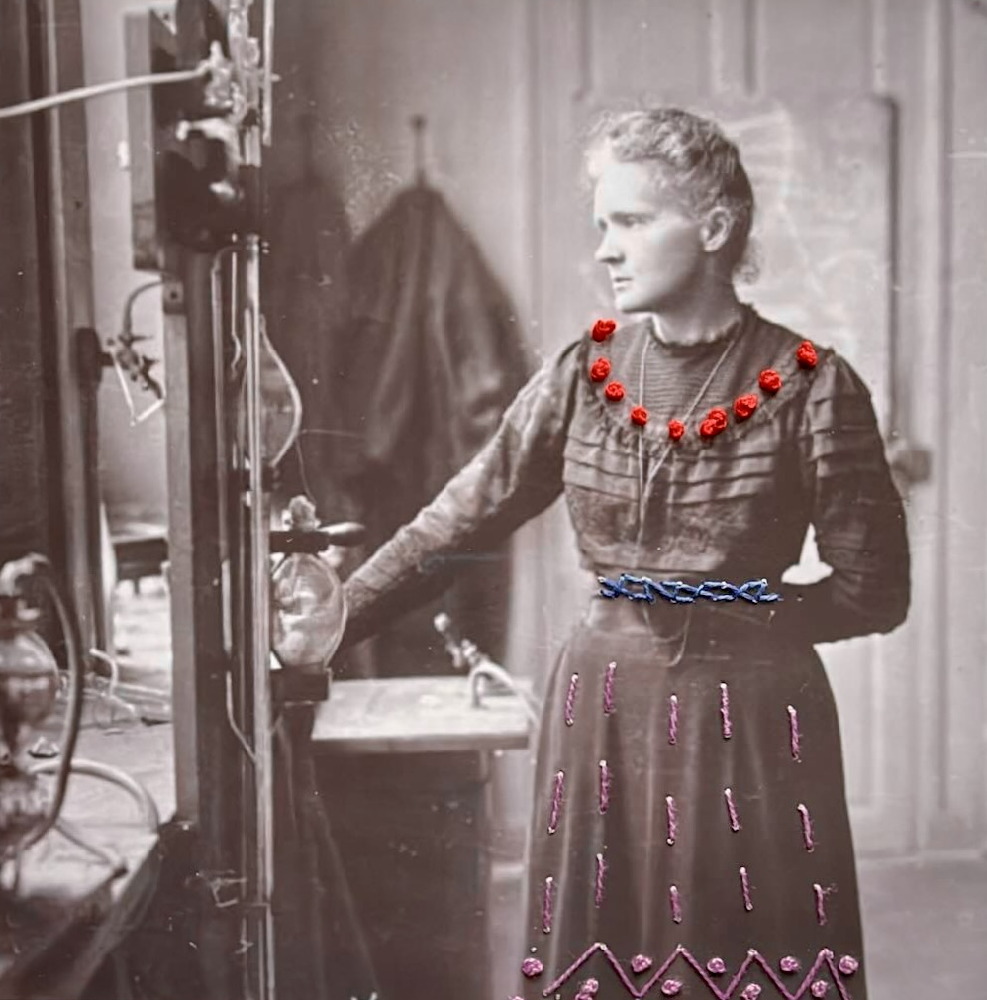

Entire banquet speech: https://www.nobelprize.org/prizes/chemistry/1911/marie-curie/speech/
Quote from the Compte-rendus of the French Academy of Sciences, 26. 12. 1898
Full speech https://www.nobelprize.org/prizes/physics/1903/ceremony-speech/
quote by František Běhounek, her student who accompanied her during the 1925 visit to Czechoslovakia
https://www.nobelprize.org/uploads/2018/06/pierre-curie-lecture.pdf
https://www.ina.fr/ina-eclaire-actu/20-avril-1995-marie-et-pierre-curie-entrent-au-pantheon

